***PAAREES PERFUMES***

***Christian Diors***

***FOR MEN***

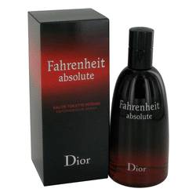

# *Fahrenheit Absolute*

***Description***

Fahrenheit Absolute by Christian Dior Cologne. A confident and stimulating scent, Fahrenheit Absolute was introduced by Christian Dior in 2009. This intense fragrance for men combines the notes of incense, myrrh, agarwood, violet and leather, which will inspire confidence each time you wear it. Ideal for special occasions, this irresistible scent will last through the night and will pique the interest of that someone special. Spritz this scent on your pulse points and drive everyone wild with curiosity of the aroma.